Shagmatic User Manual

The Shagmatic Fucking Machine is relatively simple to operate. This manual will cover both the basic operation and advanced use of the machine

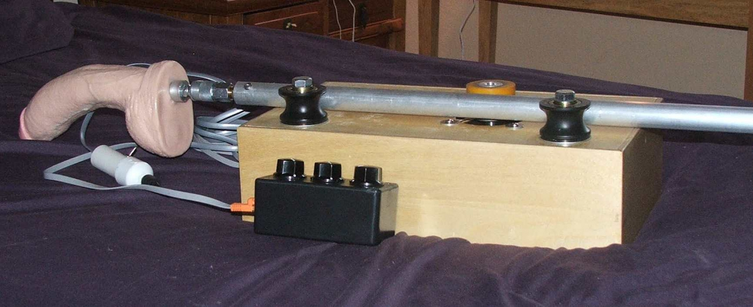.

Table of contents

Operating the Shagmatic 3

Basic Operation 3

Joystick Operation 4

Three Knob Controller Operation 4

Advanced Functions 5

Vibrator Mode 5

Emergency Stop (E-Stop) 6

Three Knob Controller Parameter Setup 6

Slave Output 7

# Operating the Shagmatic

## Basic Operation

Setup the machine for use as follows:

Place power switch in the off position.Insert power cord if it is a separate cord, not attached to the machine.With power off, insert the ram tube between the drive and idler wheels. Move it to the approximate mid stroke position.

Attach whichever controllers you want to use. You may connect a single controller or both. If you are using the "slave output" function, see the section on its use later in this document. The joystick controller must be connected to the 6 wire socket (a picture will show which connector this is in the future) closest to the USB connector. The three knob controller must be plugged into the 8 wire socket which is between the two 6 wire sockets.

If you plug a connector into the wrong socket, such as plugging a six wire cable into an 8 wire socket, no damage will be done but the machine will not work correctly and a reboot may be necessary once the cables are plugged in properly.

You may attach any toys before or after booting but the first time you run the machine it is recommended to test without any attachments.

Position the machine so that the ram will not hit anything in either extreme position. When started the machine will run to the full extended position and then the fully retracted position so it is important that there be no obstacles to this motion.

Turn the machine on and the boot process will begin. The ram will run to the fully extended position and then to the fully retracted position so be ready for this motion. It is possible to turn off this feature by placing configuration switch number four in the on position.

The machine will respond to controllers if everything has been done properly to this point.

## Joystick Operation

The joystick will control the machine with the finest detail in both time of response and accuracy of position. Simply roll the wheel over any surface and the machine will respond to the motion. You can move the roller as slowly as you want to produce delicate motion. There is a limit to the speed with which the machine can accelerate and the speed at which it can move and it is possible to move the joystick faster than this limit. The limit is determined by a number of factors including the weight of all attachments on the ram tube and the resistance to motion that any attachments might encounter. The machine will simply slip or miss motor steps if it cannot perform the requested motion.

The toggle switch controls the speed (or more accurately termed, the motion scale factor) of the joystick. There are three positions, slow medium and fast. The middle position is medium, the back position is slow and the forward position is forward. The switch will stay placed in either the slow or the medium position but it must be held in the high position. This is a safety measure to prevent unintended fast motion.

The joystick will send motion commands to the machine that it will not be able to follow. It is possible, especially in high speed setting, to command the machine to move faster than it is capable of moving. It will move as fast as it can and will slip or skip motor steps. It is also possible to command the machine to move farther forward that it is capable of moving. Once a limit switch is activated it will not move any farther in that direction. If you continue to command the machine to move past a limit switch over and over, it will continue to resist and will attempt to correct its behavior appropriately.

## Three Knob Controller Operation

The three knob controller is used for repeated motion in automatic mode. One knob controls speed, another stroke length and the third knob controls offset from the retracted position.

When the machine boots, all three parameters, speed stroke and offset, are set to zero. The repeated motion will begin as soon as the speed is increased above zero. However no motion will actually be produced until the stroke is also above zero. You may operate the machine using the offset knob alone if you set the stroke to zero but the speed must be set above zero. With no stroke the speed setting is irrelevant as long as it is above zero. If you do want control only with the offset knob it is recommended to set the speed relatively low so that an accidental movement of the stroke knob will not produce an unexpected sudden motion.

The machine responds immediately to the speed control but stroke length is only updated after completing a complete stroke. So, do not expect the stroke length to change mid stroke.

The offset knob lets you move the stroking motion forward or back without changing the length of the stroke itself. This has two primary uses. If the machine does slip, you can correct for this by changing the offset. Short and fast strokes can be produced by the three knob controller and you can also produce complex motion by using the offset control at the same time as the controlled motion. The best example of this is vibrator mode.

If you have a joystick connected as well as the three knob controller, both controls will operate simultaneously. You can set a stroke and speed and use the joystick to produce complex motion that is the sum of both controllers.

# Advanced Functions

## Vibrator Mode

If the speed control is set high and the stroke is set low the machine will act as a vibrator. The offset and joystick controls can be used to move the ram while it continues to vibrate. Since the offset setting is updated only once per stroke, the joystick works a little better together with vibrator mode.

A speed limit set in parameter setting is ignored if the stroke is less than one half inch. This allows vibrator mode to work even if the speed setting is set very low.

## Emergency Stop (E-Stop)

If the pushbutton on the three knob controller is pressed while the machine is running it will cause an immediate stop and a slow complete withdrawal. This will also occur if the three knob controller becomes disconnected while the machine is running. If the three knob controller was not plugged in at boot time, it will not be necessary to plug it in for joystick operation. E-Stop caused by cable detachment will only occur if the cable was plugged in at boot time.

## Three Knob Controller Parameter Setup

The default configuration for the three knob controller allows maximum speed and stroke. If the user does not modify these parameters the machine will work close to its design limits. A procedure is available to modify three of these parameters. Maximum speed maximum stroke and acceleration may be changed by the user. To enter parameter setup mode, first be sure the machine is switched off. Check to be sure that configuration switch number four is in the off position. Home seeking at boot is required in order for parameter configuration to work so it must be active. You can set switch four to the on position after you verify that parameter setting is correct but must set it to off any time you want to change parameters. Begin the process with the power to the Shagmatic turned off. Turn the power switch on. Wait for the ram motion to begin. Press and hold the pushbutton on the three knob controller. Parameter setting mode will be active while the pushbutton is held down. As soon as it is released the set parameters will be made active and will be written to non volatile memory. The speed knob will change the speed as always and the machine will run at that speed. The stroke knob will control stroke and the machine will run with that stroke. Once parameter setting mode is terminated by releasing the button, these values will be saved as the speed and stroke maximums. The values will be stored to non volatile memory and will continue to be the limits until they are changed by the user. The third knob does not control offset in parameter setting mode. instead it controls acceleration. Acceleration is the speed at which the machine changes from a standstill or when it reverses direction. The default value assures that the machine does not miss motor steps as it ramps the speed up in a manner consistent with the motor and driver. For most situations there is no reason to change this parameter as the effects might be a little confusing. Acceleration can be reduced to produce a very slow and safe machine. In addition to slowing acceleration, the machine speed will also be modified depending on the interaction of speed and stroke limits. Experiment with this parameter and if it does something useful, use it. Otherwise, just leave it at the default value. After a successful setting of parameters the machine will run with the new maximum values.

If you accidentally set the speed or rum maximums to zero, the machine will restore default values on the next boot. So if the machine fails to run after an attempt at changing parameters, just start it again and the default values will be restored. You can then attempt to set the parameters again. If you just can't get the machine to respond after attempting parameter setup, the following procedure is certain to restore default values: Turn the machine off and wait 30seconds. Turn the power switch on. Wait for the ram motion to begin. Press and hold the pushbutton on the three knob controller. Parameter setting mode will be active while the pushbutton is held down. Do not turn any of the three knobs until the button is released. Release the button 2 seconds after the ram has returned to the fully withdrawn position. The machine will be disabled and the default parameters restored. Shut off for a minimum of 30 seconds. The machine will be restored to factory setting on the next start.

## Slave Output

The socket farthest from the USB socket provides signals that mirror the joystick signals. This may be used to control another Shagmatic machine. A six wire cable is plugged into the slave output connector of the master machine and to the joystick connector of the slave machine. This way, one joystick can be used to control virtually any number of machines. There is no limit to the number of machines that can be connected in a series. There will be approximately one millisecond delay from one machine to the next.

Each machine will be limited by its own limit switches so it may not be possible for a slave machine to produce the same motion if it has a shorter ram. It is also possible for the machines to get out of sync due to slipping or different current limit setting.

If it seems that the machines are out of sync, use the joystick to return the master machine to the fully retracted position and continue to move the joystick in that same direction if necessary to return the slave machine to the fully retracted position as well.

When operating machines in slave/master control it is best to use machines of similar construction and with rams of the same length. Also it is best to avoid extreme motions that may be met with more resistance on one machine than the other. Nothing terrible will happen if you ignore these suggestions but the machines may get out of sync again and again.

The three knob controller will operate only the machine it is connected to. Signals from the three knob controller will not be passed to the slave machine. You may use a three knob controller on each machine. The signals from the master joystick will merge with the signals of the three knob controller on each machine. This is useful if, for example, you want to have each machine in vibrator mode with joystick control.